Science workshop has been created by Grete Jaeski, Elina Tall and Koit Krusberg (Form 11.TE, supervisor Agnes Vask, Tartu Tamme Gymnasium 2017/2018).
The workshop has created and carried out by the support of European Union: ERF (project „Teeme+“, https://tammegymnaasium.ee/teemeplus-projekt/)
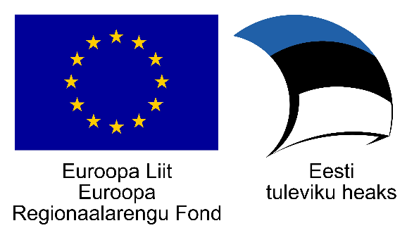

Worksheet for students

Task 1. Symbols used for sketching the electric circuits.

Switch Power source

Power consumer (lightbulb) Voltmeter

Ammeter Resistor

Wiring connection Crossing of wires

Test 1. Draw the circuit schematics of serial connection of resistors. Afterwards, construct the circuits and measure the current and voltage and calculate the resistances.

Resistor nr 1 current strenght:

Resistor nr 2 current strenght:

Resistor nr 1 voltage:

Resistor nr 2 voltage:

Resistor nr 1 resistance:

Resistor nr 2 resistance:

Test 2. Draw the circuit schematics of parallel connection of resistors. Afterwards, construct the circuits and measure the current strengths and voltages and calculate the resistances.
Resistor nr 1 current strenght:

Resistor nr 2 current strenght:

Resistor nr 1 voltage:

Resistor nr 2 voltage:

Resistor nr 1 resistance:

Resistor nr 2 resistance:

